od8/29 CSP P4E chp2 notes:

### **Overview**

**Chapter 2: Variables, Expressions, and Statements**

### **2.1 Values and Types**

* **Definition of Values:** A value is one of the basic things a program works with, like a letter or a number.
* **Types of Values:**
  + *Integers* are just numbers. Example: 2
  + *Strings,* so called because it contains a “string” of letters.You can identify strings because they are enclosed in quotation marks. Example: “Hello, World!”
  + *Floating points,* are numbers with a decimal point, they belong to a type called float
* Even if you put “17” or “3.2” with quotation marks, they become strings.
* Commas are not a legal integer in Python, it won’t give an error but for example: print(1,000,000) gives you “1 0 0”.

### **2.2 Variables**

* **Definition of Variable:**  A variable is a name that refers to a value.
* **Assignment Statement:** An assignment statement creates new variables and gives them values.
* 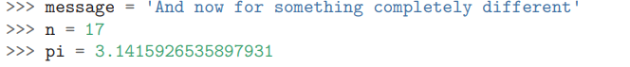

**2.3 Variable Names and Keywords**

* **Naming Rules:**They can contain both letters and numbers, but can’t start with a number. It is legal to use uppercase letters, but isn't’ the best idea.
* **More rules**: Underscores are common, but not recommended to start a word with. Cannot contain illegal characters like “@”. Cannot include reserved 35 words.
* 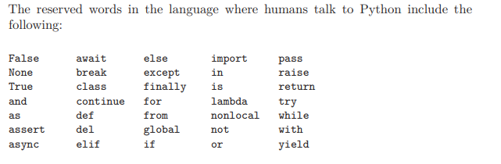
* **Python Keywords:**^

### **2.4 Statements**

* **Definition:** A *statement* is a unit of code that the Python interpreter can execute.
* A *script* usually contains a sequence of statements. If there is more than one statement, the results appear one at a time as the statements execute.

### **2.5 Operators and Operands**

* **Operators:** Operators are special symbols that represent computations like addition and multiplication +, -, *, /, and ** perform addition, subtraction, multiplication, division, and exponentiation,
* **Operands:** One of the values on which an operator operates.
* In Python 2, when dividing 2 integers it would remove the float to keep it whole, so to emulate it now, To obtain the same answer in Python 3 use floored ( // integer) division.

### **2.6 Expressions**

* **Definition:** An *expression* is a combination of values, variables, and operators. A value all by itself is considered an expression, and so is a variable, so the following are all legal expressions
* **Examples:**
* in a script, an expression all by itself doesn’t do anything! This is a common source of confusion for beginners

### **2.7 Order of Operations**

* **PEMDAS:** Parentheses, Exponents, Multiplication and Division, Addition and Subtraction

### **2.8 Modulus Operator**

* **Definition:** The modulus operator works on integers and yields the remainder when the first operand is divided by the second. The modulus operator is a percent sign (%).
* **Examples:** 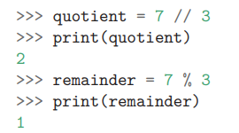
* **Other uses:** For example, you can check whether one number is divisible by another: if x % y is zero, then x is divisible by y
* **More:** You can also extract the right-most digit or digits from a number. For example, x % 10 yields the right-most digit of x (in base 10). Similarly, x % 100 yields the last two digits.

### **2.9 String Operations**

* **Concatenation:** + performs concatenation, Joining the strings by linking them end to end. . If you make a variable with ‘integer’ and 2 of them. It would add like this “ ‘69’ +’1’ =691
* **Repetition:** The * operator also works with strings by multiplying the content of a string by an integer. first = 'Test ', second = 3, print(first * second), Test Test Test
* **Indexing:** [How to access specific characters in a string]

### **2.10 Asking the User for Input**

* **Input Function:** 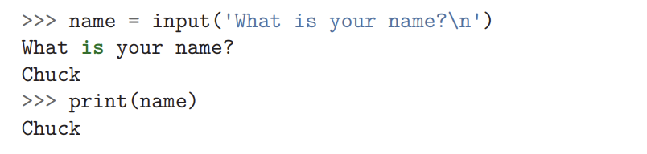
* 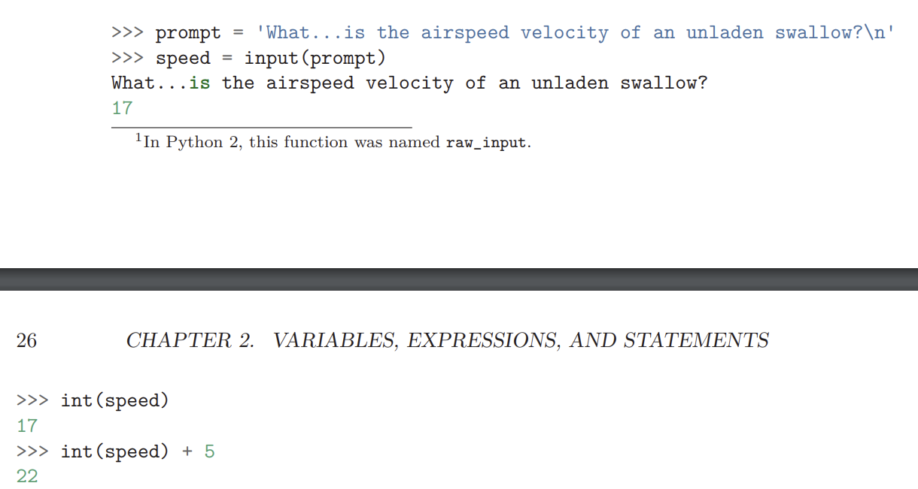newline=n
* However if the user types something other than a string of digits, you get an error

### **2.11 Comments**

* **Single-Line Comments:** These notes are called comments, and in Python they start with the # symbol: # compute the percentage of the hour that has elapsed
* **Uses :**Comments are most useful when they document non-obvious features of the code.

### **2.12 Choosing Mnemonic Variable Names**

* **Wisely chosen variable names “mnemonic variable names”.**]
* **Examples:** But if our program is truly about reading data and looking for words in the data, pizza and slice are very un-mnemonic variable names. Choosing them as variable names distracts from the meaning of the program.

### **2.13 Debugging**

* **Common Errors:**
* cant have spaces or illegal characters in variables
* Variable names are case sensitive, so LaTeX is not the same as latex.
* At this point, the most likely cause of a semantic error is the order of operations.
* **Debugging Techniques:** Techniques for finding and fixing errors in code

### **2.14 Glossary**

* **Key Terms:** 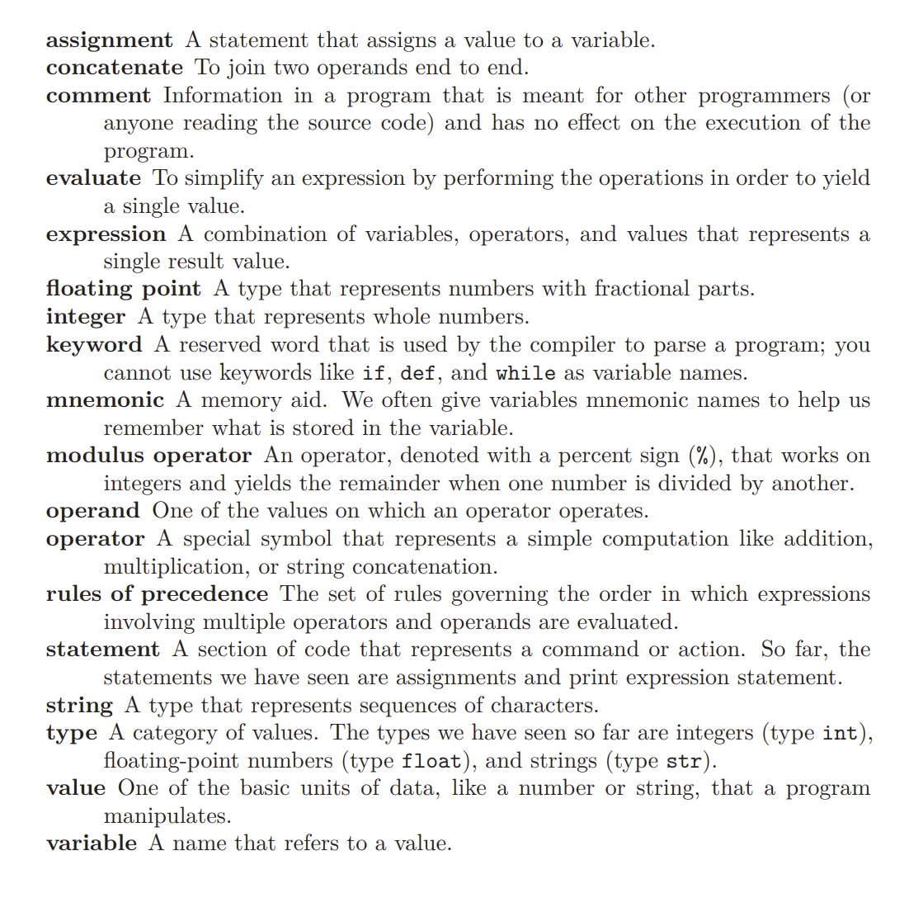

### **2.15 Exercises**